Leader

## This Team’s Current Debt

The current largest pain point is that bugs cross between code from several teams. Bugs bounce back and forth and get blocked on other teams.

## Last Meeting’s Hypothesis

* Bugs aren’t prioritized equally for all teams.
* Cross team communication and prioritization needs improved.

## This Meeting’s Goal

* **Team** is sharing results of this line of inquiry.
* **Leader** wants to improve team’s ability to own tech debt.

## Beliefs

The problem is clearly that bugs that bounce between teams and then sit there with no action for days.

## Remember Your Stance!

* Ownership is more important than the team finding the right solution immediately.
* The team has more info than you, always.
* Learning happens when there are unexpected outcomes. You don’t want everything to happen as planned or hoped!
* If the team asks for ideas, help them create options rather than give direction.

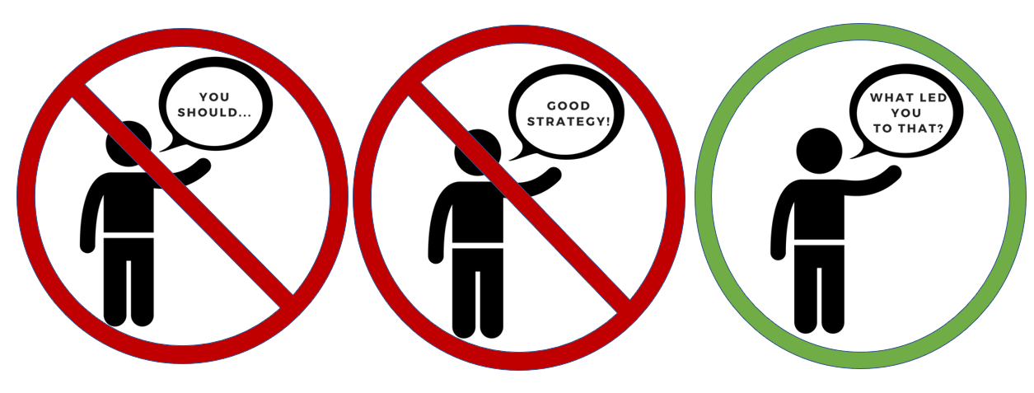

Team

## This Team’s Current Debt

The current largest pain point is that bugs cross between code from several teams. Bugs bounce back and forth and get blocked on other teams.

## Last Meeting’s Hypothesis

* Bugs aren’t prioritized equally for all teams.
* Cross team communication and prioritization needs improved.

## This Meeting’s Goal

* **Team** is sharing results of this line of inquiry.
* **Leader** wants to improve team’s ability to own tech debt.

## Beliefs

Tracking and communication experiments are simply not fixing it.

Diagnosing these bugs is hard because 1) it requires deep knowledge, 2) the information is arcane, and 3) only a few people understand the code well.

Key individuals lose time thrashing between tasks, and bugs block on them.

Everybody on both teams are trying to do the right thing.

## Remember Your Stance!

* You own this. You probably know more than the leader.
* Don’t try to convince; just try to show what is true.
* If you need a resource, ask for it. But labor is not a resource – your labor is your own and you don’t have to ask for it.

|  |  |
| --- | --- |
|  |  |

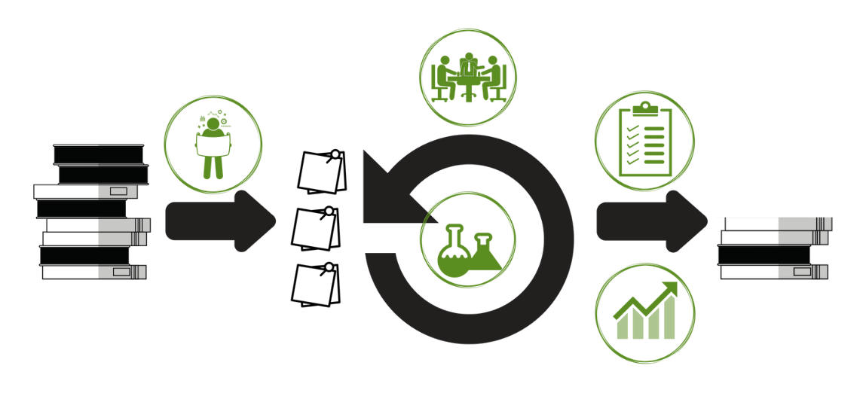

|  |  |  |  |
| --- | --- | --- | --- |
| **PLANNING EXPERIMENTS** | | | |
|  | **ACTIONS** | 1. Review your pain 2. Agree what hurts most 3. Decide how to measure progress at pain reduction 4. Define how you will measure that 5. Define some experiments to try 6. Define some improvements based results of past experiments | |
| **RUNNING EXPERIMENTS** | | | |
|  | **ACTIONS** | During **planning**, decide:   * Improvement vs Experiment * Impact Measurement | In **tracking**, note:   * Did we finish the work? * What happened to the impact measure? |
| **LEADING OWNERSHIP** | | | |
|  | **ACTIONS** | **Logistics**  Meet weekly for 7 min  Attendees: Executive, Team  Optional: Other teams under same executive  **Intent**  Team: Show current decisions  Executives: Coach on ownership | **Team Agenda**:   * What was learned since last time? * How did that insight change what we measure? * Any overall changes in technical strategy * Any resources we need, and on what timeline?   **Executive Agenda:**   * Ask what informed any specific decision * Note successful ownership moments |
| **ASSESSING OWNERSHIP** | | | |
|  | **ACTIONS** | * Which teams need my help? * Which teams should be left alone?     Score teams on their ability to prioritise, handle the unknown, learn & execute, and decide well.  *See Team Assessment Rubric for specific criteria within these categories.* | |
| **SHOWING IMPROVEMENT** | | | |
|  | **ACTIONS** | Add to the demo agenda the following items:   * Target measure * Experiments run * Results * Any strategy shifts (measure or experiments) for next week. | |

|  |  |  |  |  |
| --- | --- | --- | --- | --- |
|  | **GOAL** | **INDICATORS** | **VALUE LEVEL** |  |
| **Learning and Execution** | Have hypotheses | Each card has an impact measure, in addition to acceptance criteria. | High |
| Incorporate learning | At least 70% of experiments result in a specific, substantial change in future plans or execution. | High |
| Improvement is visible within team | Each day, everyone in the team knows what specific improvement the team is working on and can see their immediate results. | High |
| Optimize for learning | About 50% of experiments deliver their impact. | Medium |
| Still deliver well | >90% of improvements deliver their impact. | Medium |
| Improvement is happening | Team agrees what better means from a business perspective and is improving on that each quarter. ROI is known | Medium |
| Improvement is visible to project community | At least weekly, all stakeholders can see the specific improvements the team is making, in business terms. | Medium |
| **Deciding Well** | Right people decide | Made by those impacted by the outcome, not by those nominally responsible | High |
| No outside vetos | Once a decision is reached, it is not overturned by someone who wasn’t in the room | Medium |
| Decision-making is fast, clear, and incorporates information equally | Decisions take <10 min to make; pre-decision discussion is done such that all information and perspectives are incorporated, yet still completes in <30 min. | Medium |
| Decisions incorporate info from others | Each decision asks what important info might be held outside the room, and pauses to gather that info before deciding | Lower |
| **Prioritization** | The planned work that doesn’t get done should be evenly distributed among features, experiments, and improvements. | % non-complete. Total, and segmented by card category. | Medium |
| Team follows its budget. | When exiting the sprint planning, the cards reflect that budget, for each category. | Medium |
| The team has an intentional budget for tech debt. | Everyone on team, including PO, agrees on how much effort is spent where and how that is computed. | Lower |
| **Handling the Unknown** | Team knows how much unknown work will appear during the sprint. | Measure exists. | Medium |
| Sprint plan leaves space for unknown work. | At exit of sprint planning, the planned work leaves space for the unknown. | Medium |
| Unexpected work is triaged well | The right work is pushed off to next sprint, regardless of whether it was planned or unplanned. | Lower |